11.94: a) Taking torques about the point where the rope is fastened to the ground, the lever arm of the applied force is and the lever arm of both the weight and the normal force is 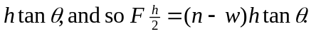 Taking torques about the upper point (where the rope is attached to the post), 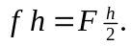Using 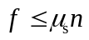 and solving for F,
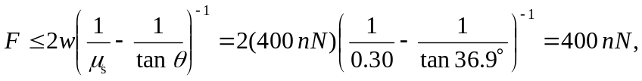
b) The above relations between 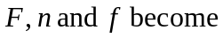
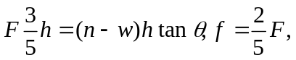
and eliminating 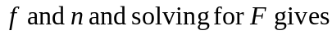
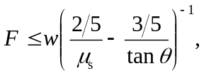
and substitution of numerical values gives 750 N to two figures. c) If the force is applied a distance y above the ground, the above relations become

which become, on eliminating 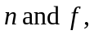
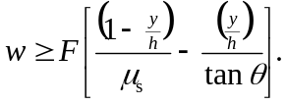
As the term in square brackets approaches zero, the necessary force becomes unboundedly large. The limiting value of y is found by setting the term in square brackets equal to zero. Solving for y gives
